Title: Seven Colours
School: Christ Church C of E Primary School, Cheltenham
First name of child: Theo
School year of child: Year 1
Explanation of work: All the bright colours that are around us.

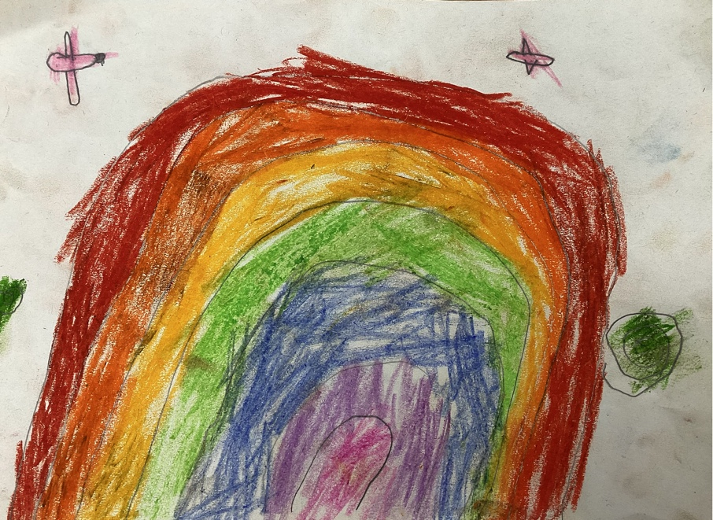

Title: The Creation
School: Christ Church C of E Primary School, Cheltenham
First name of child: Ruari
School year of child: Year 1
Explanation of work: God didn’t just create the world, he created the planets too.

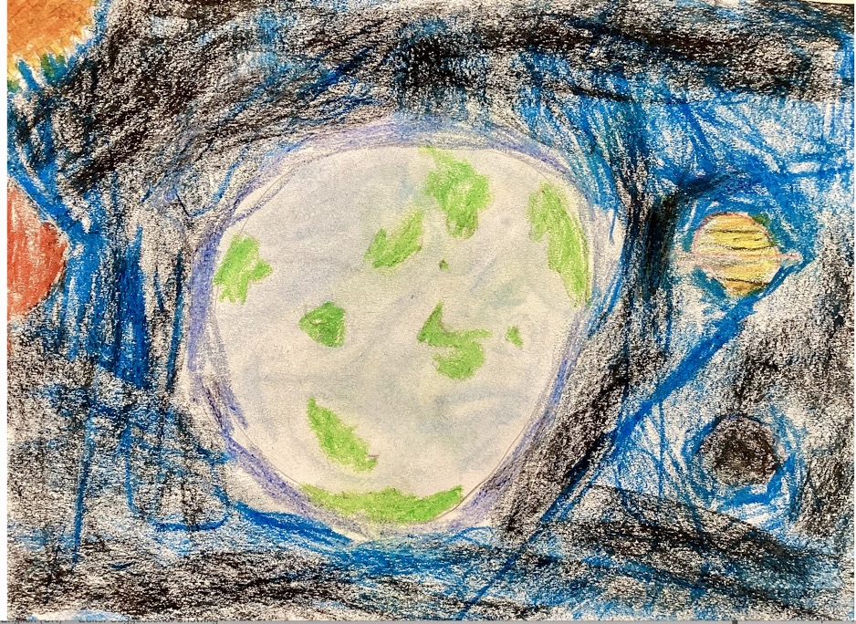

Title: Flying in the sky
School: Christ Church C of E Primary School, Cheltenham
First name of child: Isla
School year of child: Year 1
Explanation of work: Thank you for the creatures. Some are tiny like these butterflies.

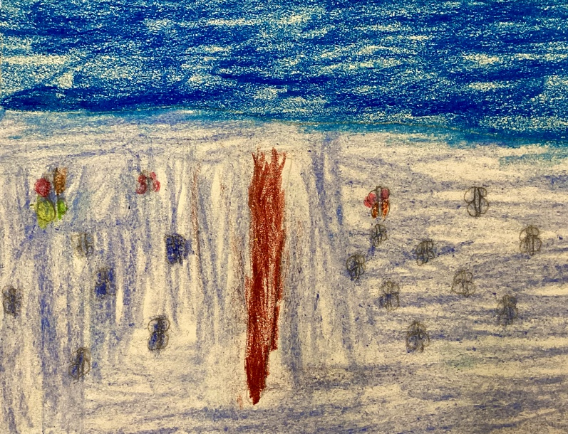

Title: Both sides
School: Christ Church C of E Primary School, Cheltenham
First name of child: Lucas
School year of child: Year 3
Explanation of work: My world view picture is of both sides of the beach and that both sides are beautiful but unique and also the lighthouse symbolises that God’s light always shines.

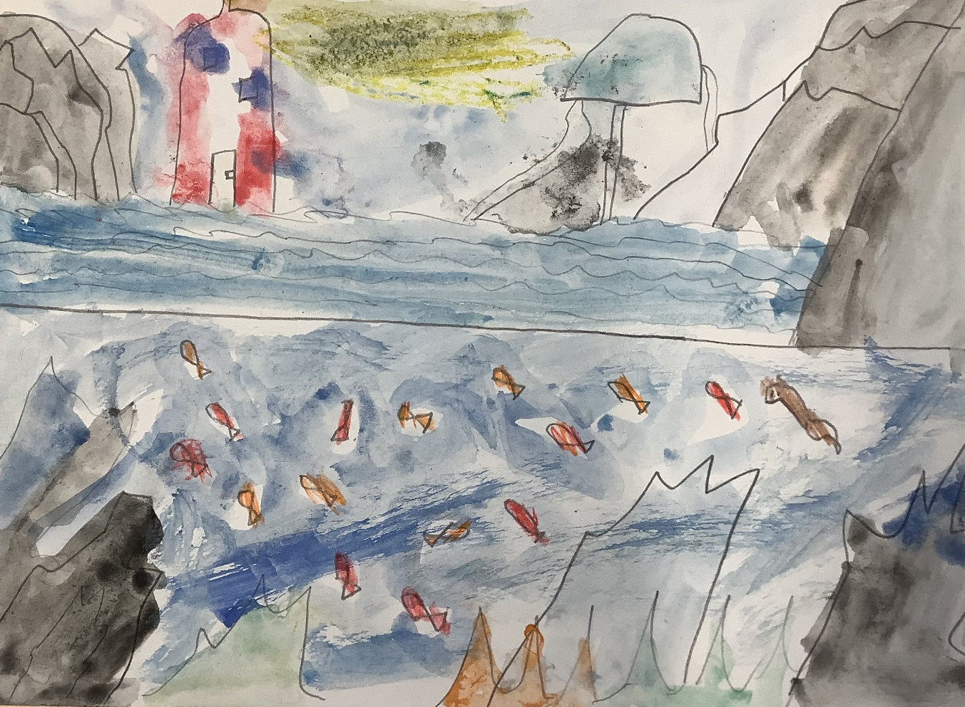

Title: Reflection
School: Christ Church C of E Primary School, Cheltenham
First name of child: Eleanor
School year of child: Year 3
Explanation of work: My world view is of the ocean with the light of the sun. I chose this because the light is like God peering down at us on his beautiful earth below.

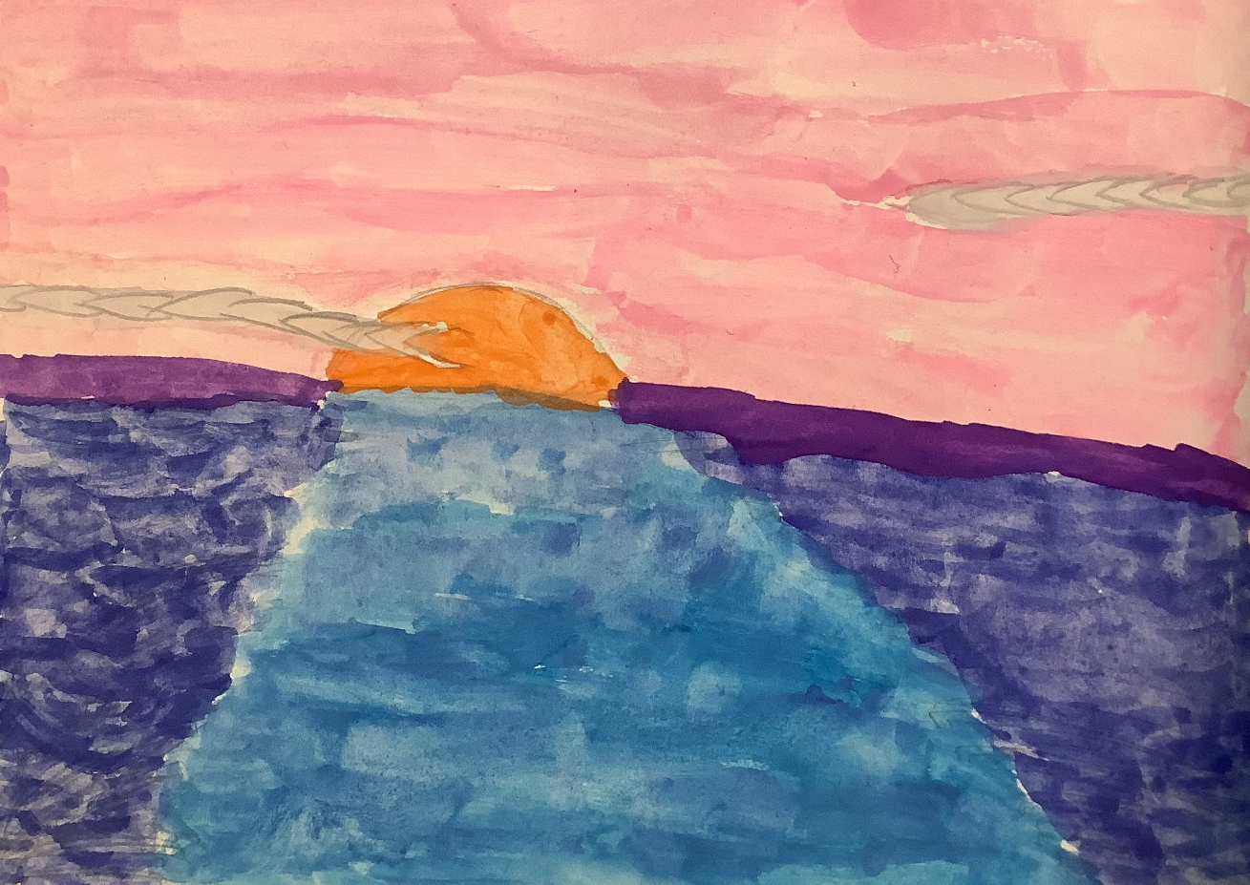

Title: BIG WORLD
School: Christ Church C of E Primary School, Cheltenham
First name of child: Thomas
School year of child: Year 3
Explanation of work: My world view is called the BIG WORLD because it reminds me of the incredible Creation Story from the Bible. WOW – what a big world!

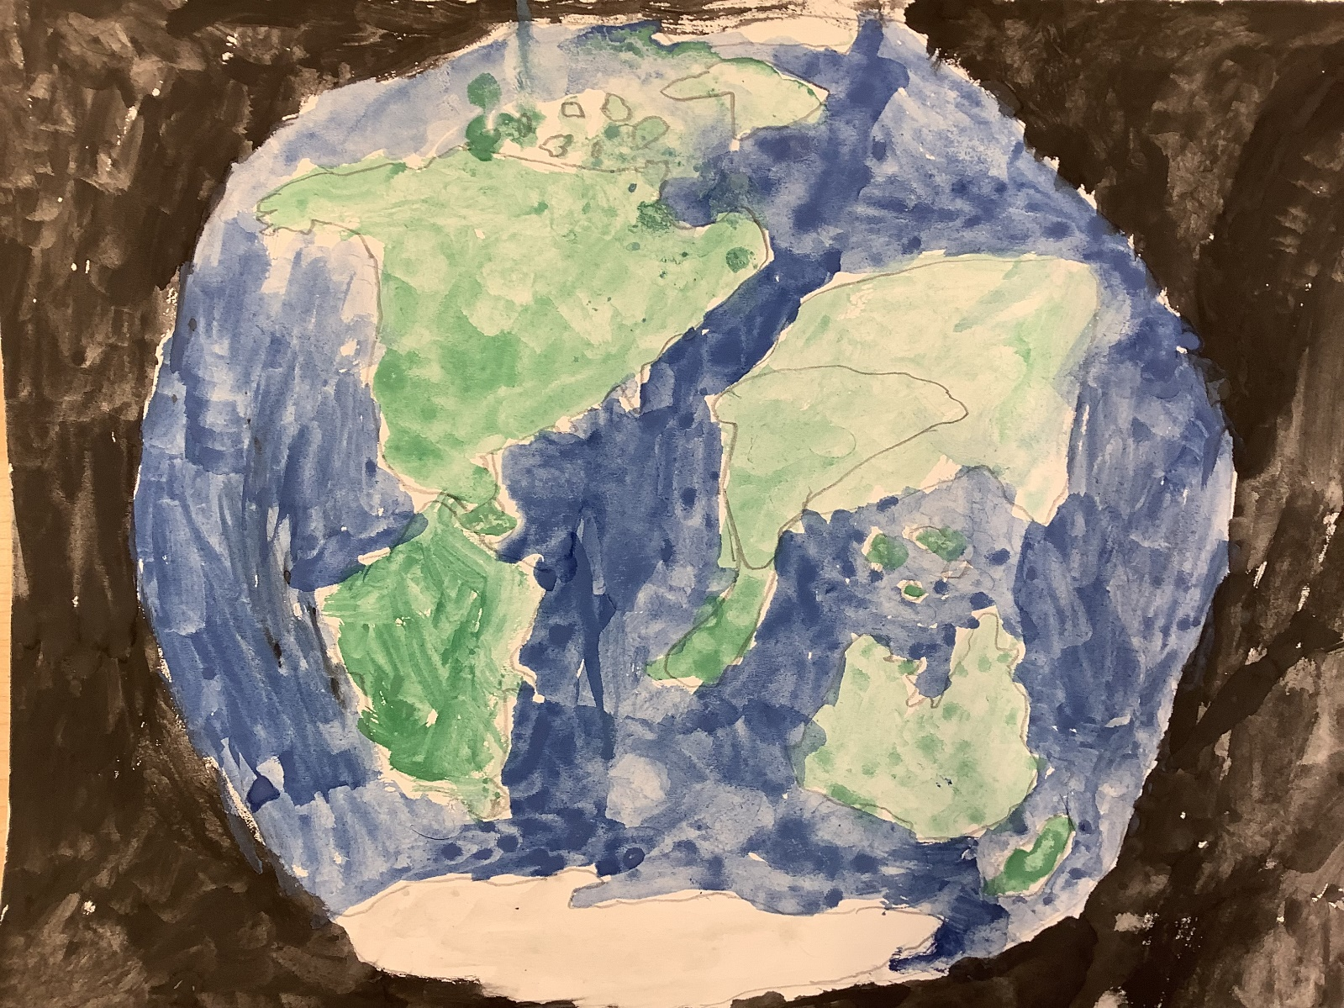

Title: Day / Night
School: Christ Church C of E Primary School, Cheltenham
First name of child: Frankie
School year of child: Year 2
Explanation of work: My world view picture is called Day/Night because I believe God created the dark sky but he didn’t leave it dark - he put light into that darkness. The sunlight is for the day which helps the flowers and plants to grow.

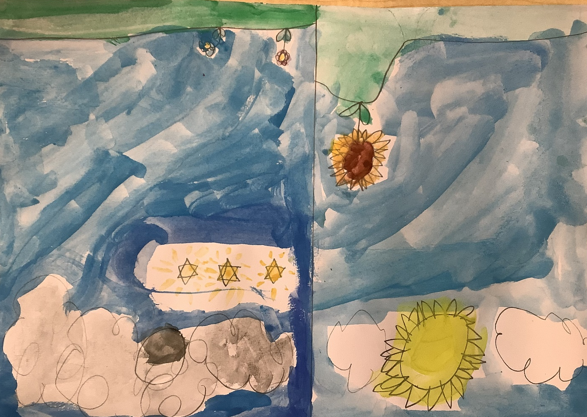

Title: Sunset sky
School: Christ Church C of E Primary School, Cheltenham
First name of child: Jessie
School year of child: Year 2
Explanation of work: My world view picture is showing a beautiful sunset sky with the orange, reds and yellows. God made the world and the leaves falling from the autumn trees reminds me of the changing seasons.

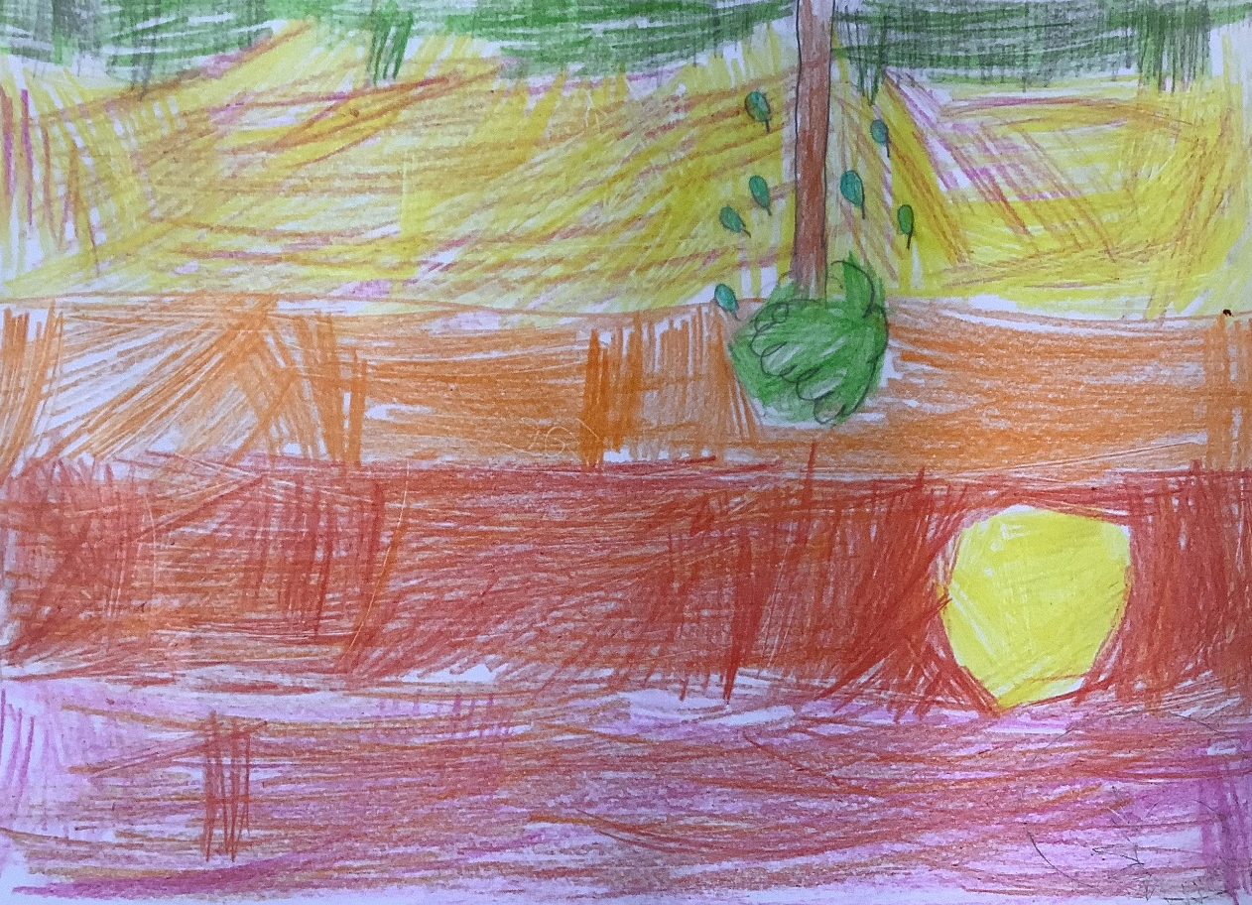

Title: The Jiggly Jungle
School: Christ Church C of E Primary School, Cheltenham
First name of child: Reuben
School year of child: Year 2
Explanation of work: My world view picture reminds me that God created the world including these amazing animals so we can enjoy them. I believe God is a creator and he’s like our Dad with Jesus his son and the holy spirit.

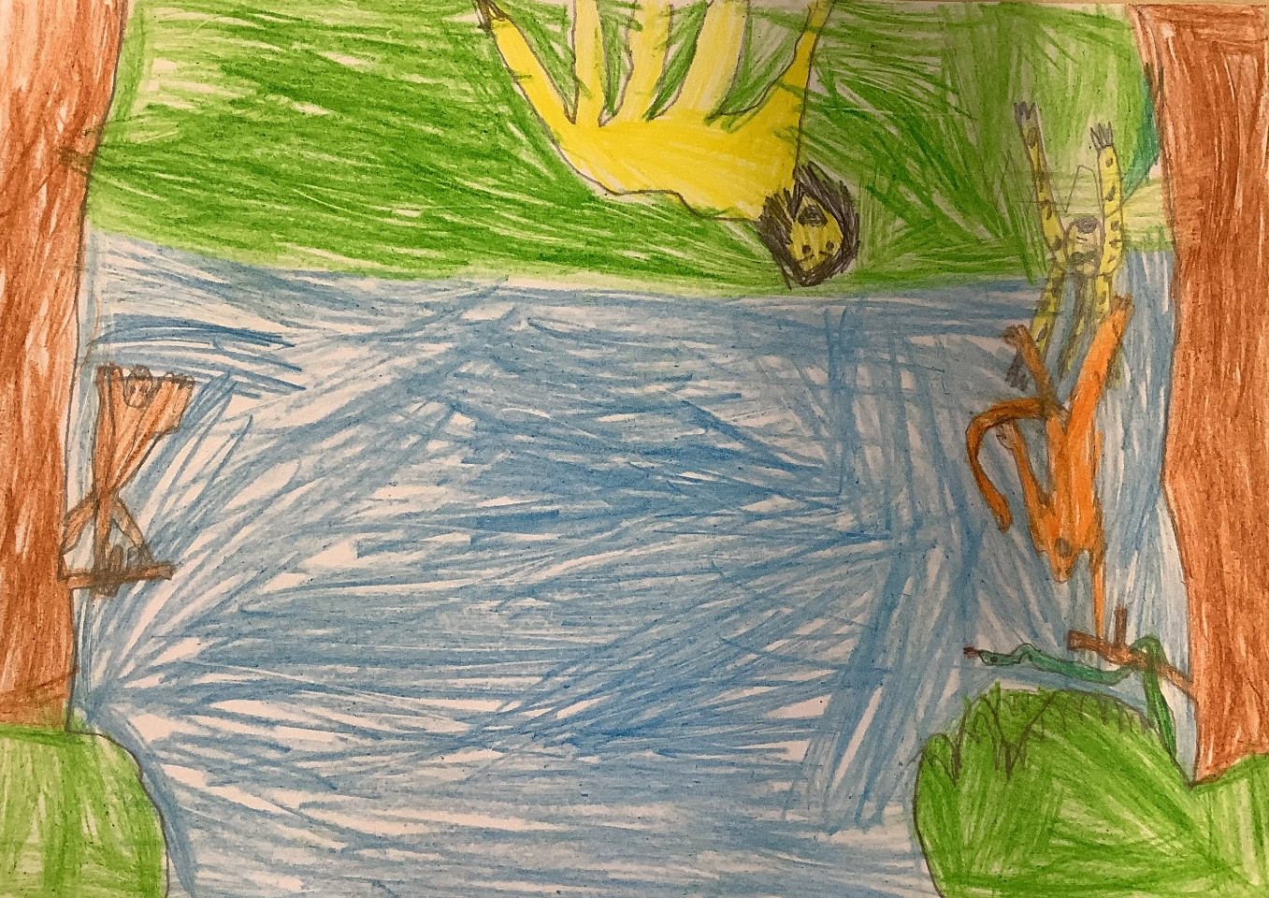

Title: Tree / eerT
School: Christ Church C of E Primary School, Cheltenham
First name of child: Michael
School year of child: Year 4
Explanation of work: My picture of this world view shows a tree in the sunset and a reflection in the water. This represents that it doesn’t matter which way you look at nature, it is always beautiful.
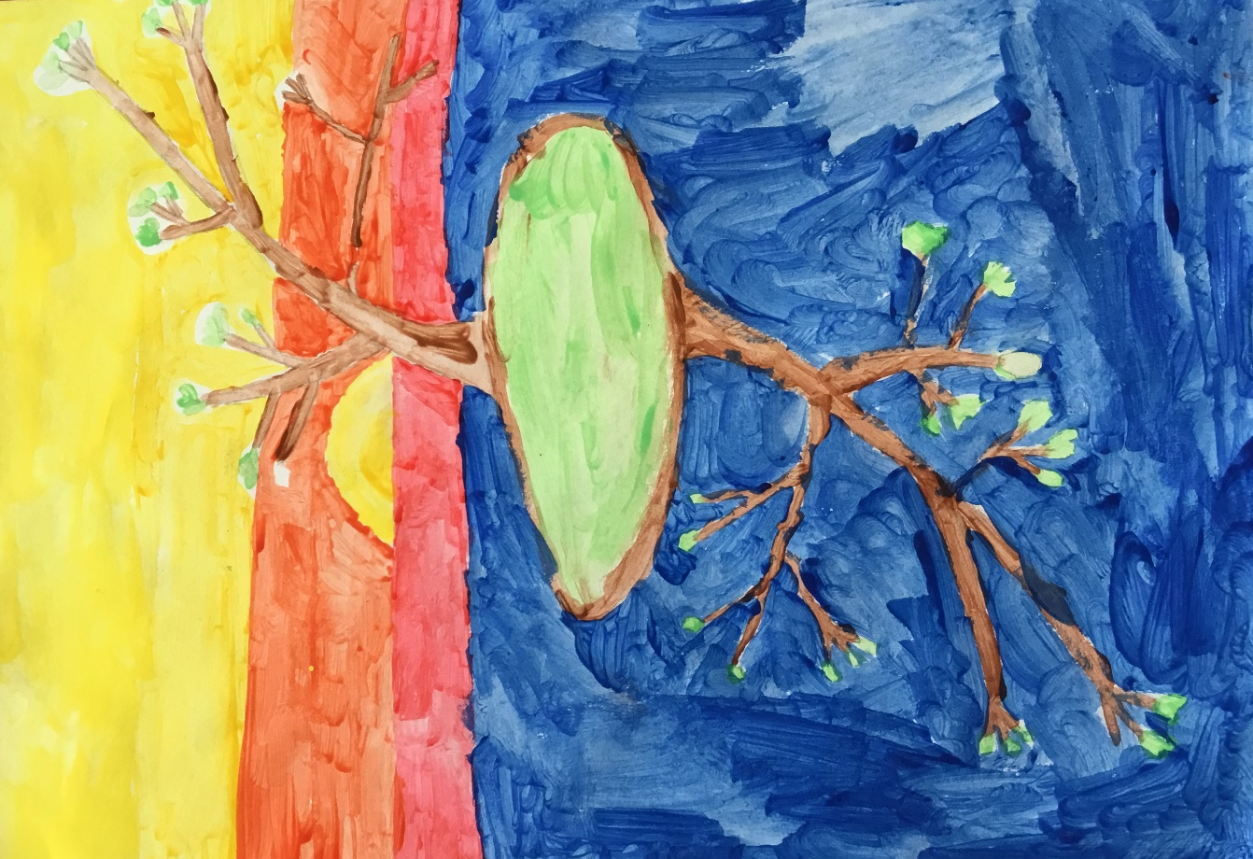

Title: Love is Living
School: Christ Church C of E Primary School, Cheltenham
First name of child: Elsa
School year of child: Year 4
Explanation of work: My picture of this world view is of a candle called “Love is living” because God’s light doesn’t just fill the room, it fills your day and with God, all things are possible.

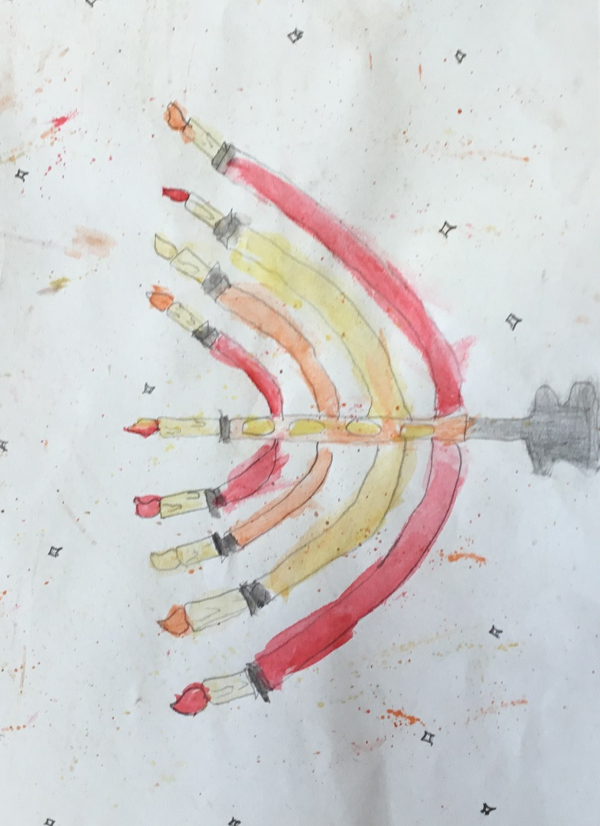

Title: Strong Roots
School: Christ Church C of E Primary School, Cheltenham
First name of child: Theodore
School year of child: Year 4
Explanation of work: My picture of this world view is of a tree with strong roots because no matter how small your platform is, you are still standing strong.
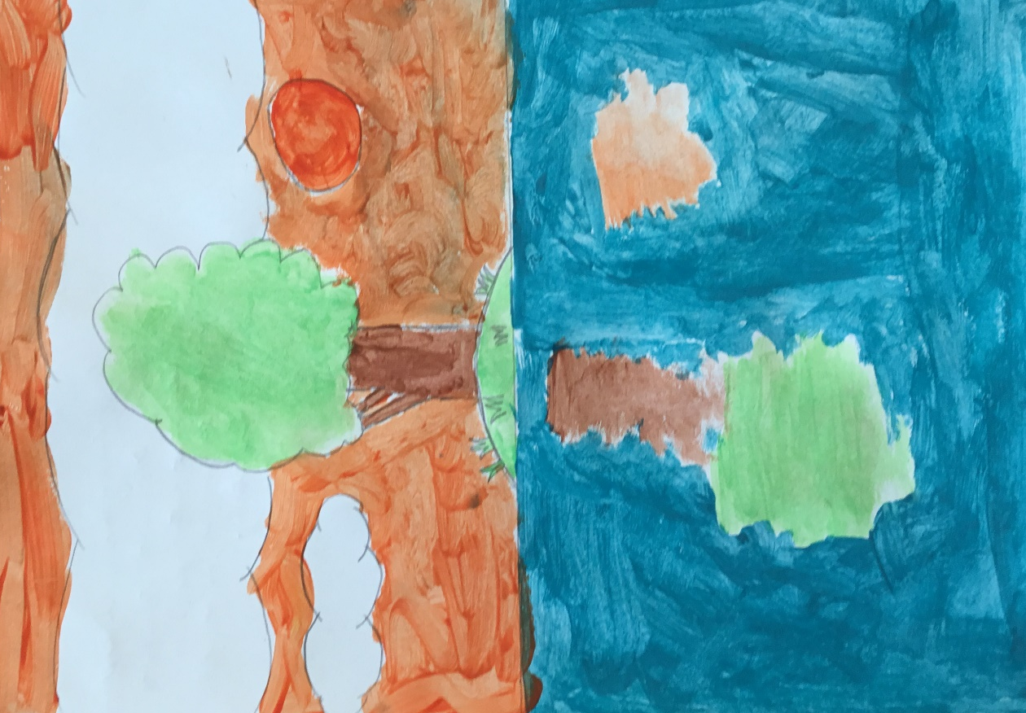

Title: Wonderful World
School: Christ Church C of E Primary School, Cheltenham
First name of child: Flynn
School year of child: Year 5
Explanation of work: My picture shows that every bit of religion builds our wonderful world. The picture also has religious symbols like the moon, dove or stars and the Om on his frisbee. A picture is worth a thousand words and yet mine is worth two thousand.
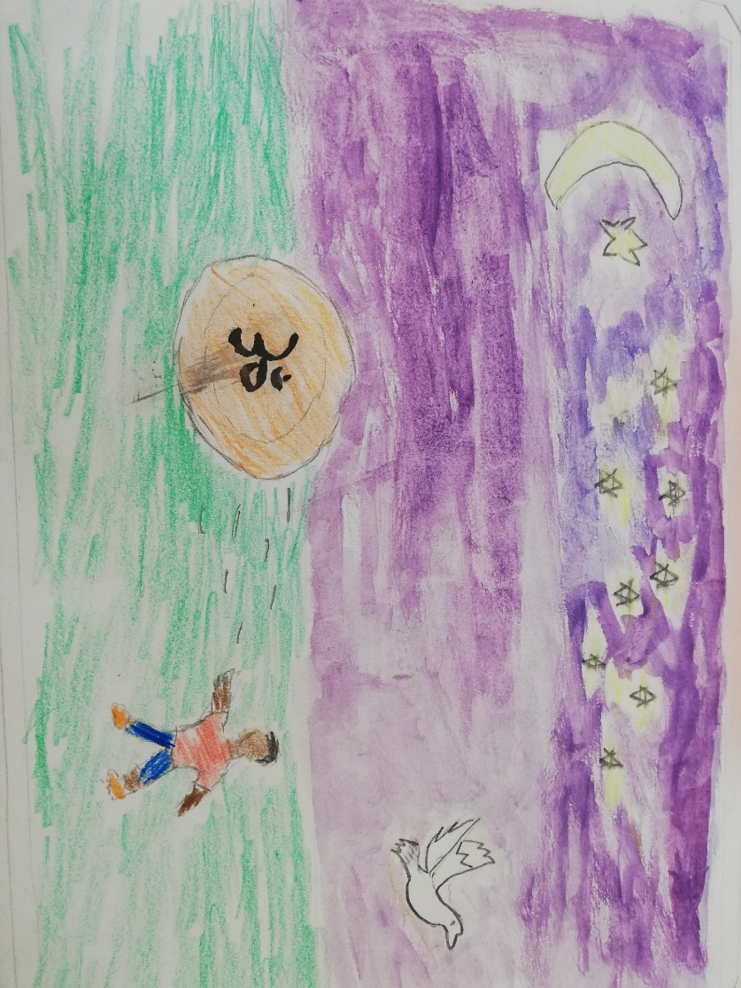

Title: Tranquil Night
School: Christ Church C of E Primary School, Cheltenham
First name of child: Logan
School year of child: Year 5
Explanation of work: This is showing how there is a man on a cliff looking at a church and a dove is flying overhead. There is a blending sunset with a dark and lonely man reflecting on the tranquil night.
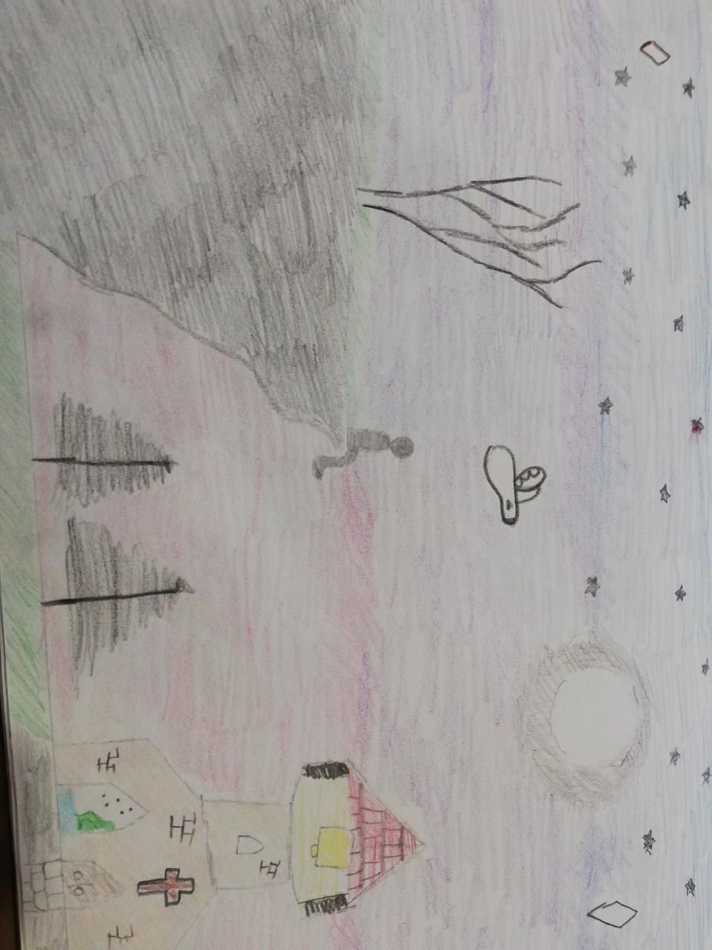

Title: Protection from the Darkness
School: Christ Church C of E Primary School, Cheltenham
First name of child: Jessica
School year of child: Year 5
Explanation of work: My picture of the world view is the cross Jesus died on protecting us from the darkness and evil. The ones who are dark and evil are protected because God always forgives people even if they have done something wrong.
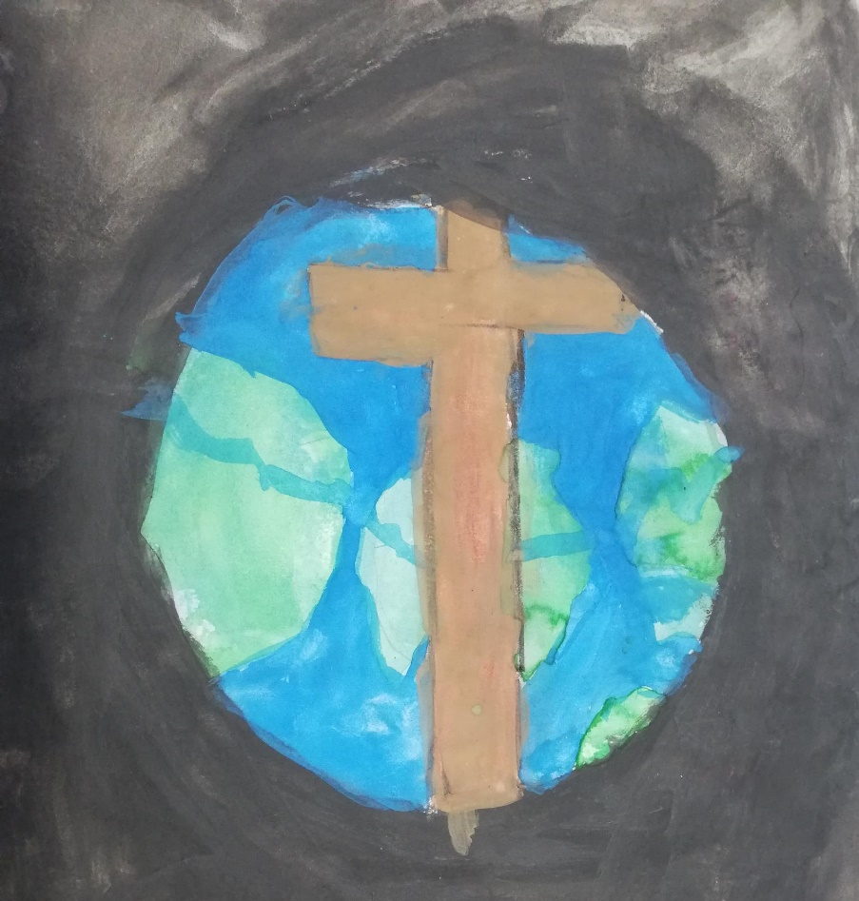

Title: Faith of Budda
School: Christ Church C of E Primary School, Cheltenham
First name of child: Alex
School year of child: Year 6
Explanation of work: My picture is about the real world meaning of karma and that nothing lasts forever.

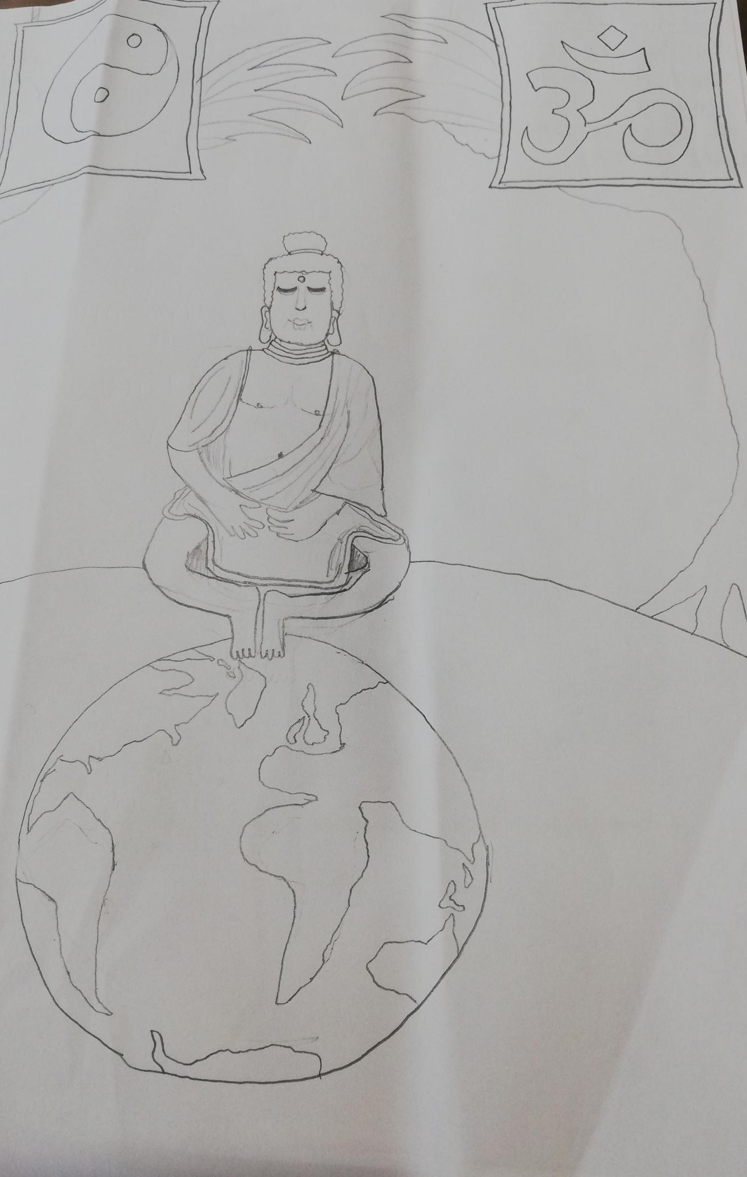

Title: Believe
School: Christ Church C of E Primary School, Cheltenham
First name of child: Ruby
School year of child: Year 6
Explanation of work: My drawing symbolises that everyone can change using God as a guide and signpost.
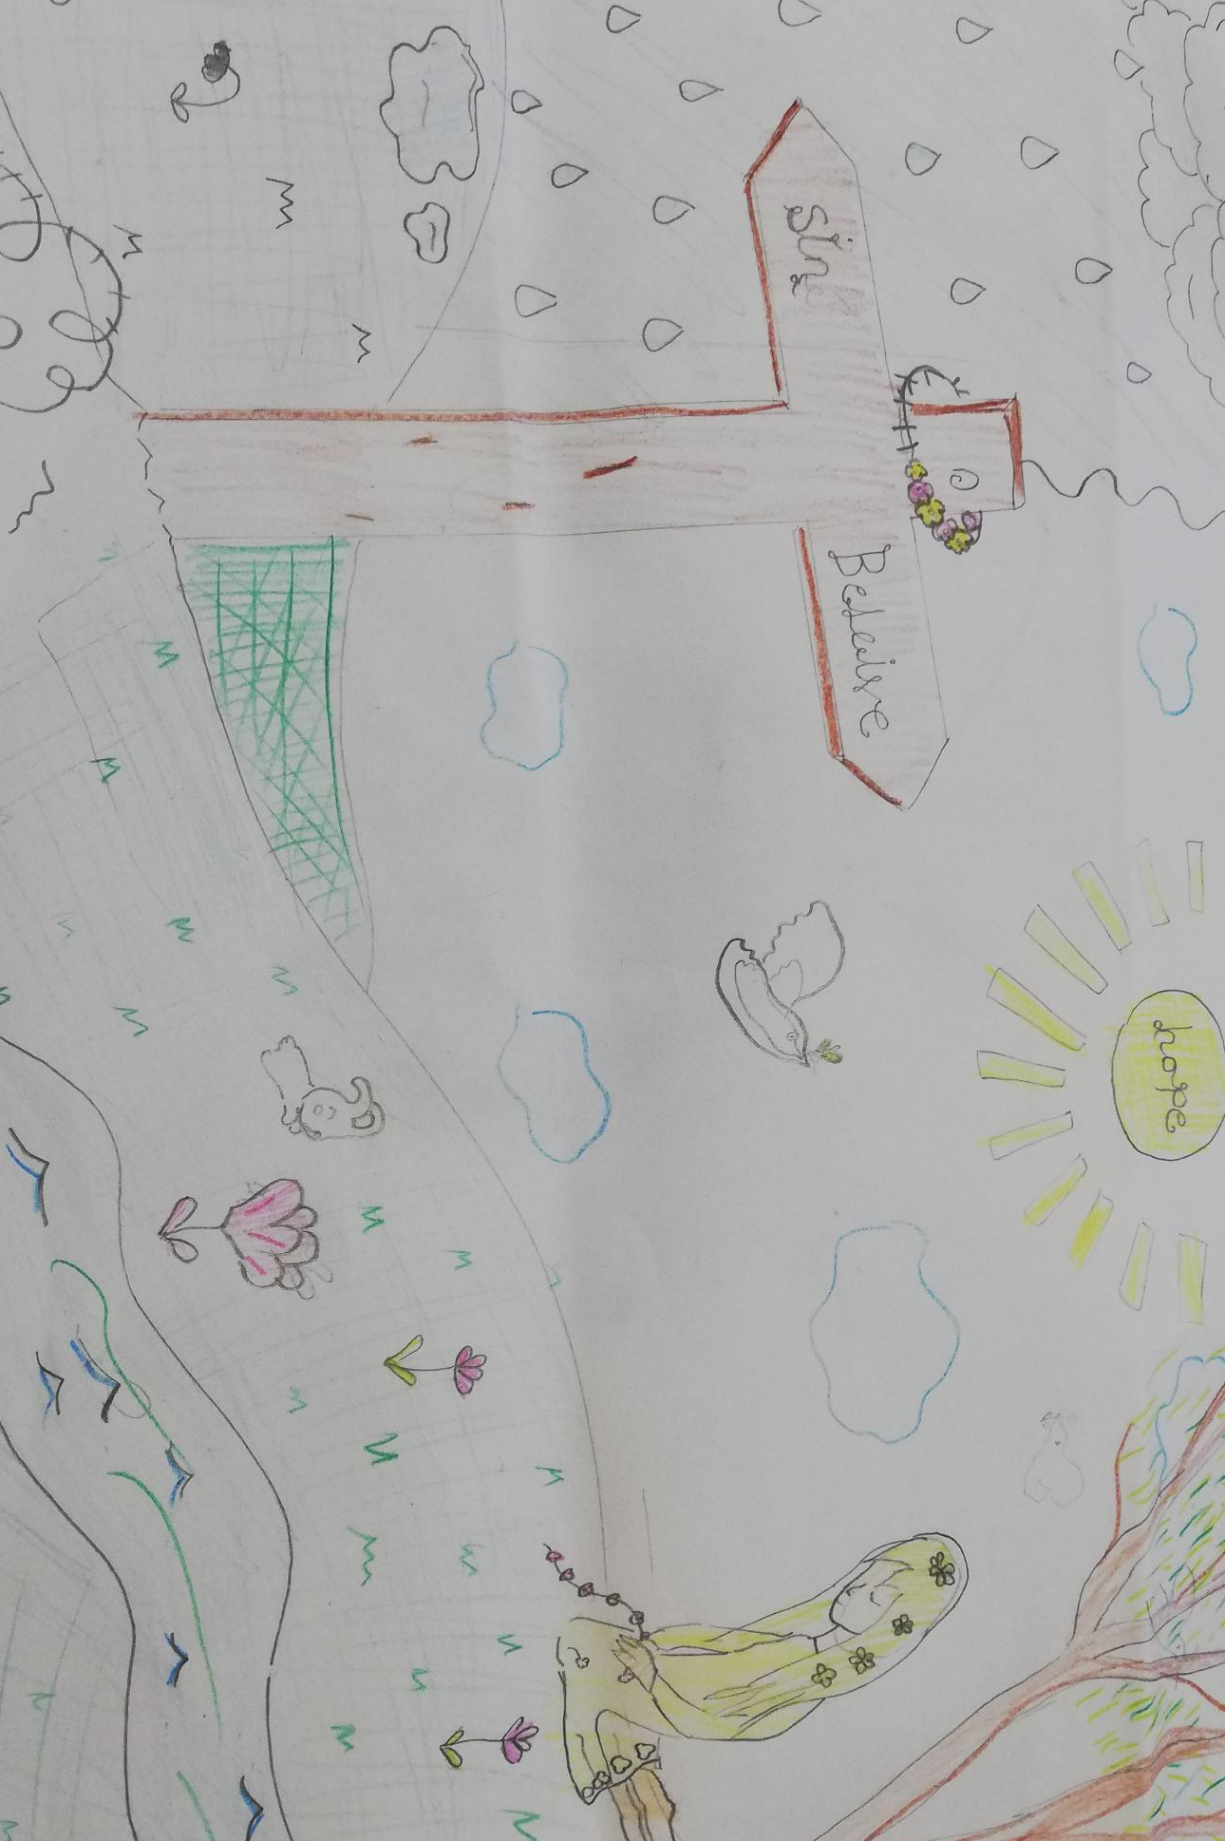

Title: Chasing the Light
School: Christ Church C of E Primary School, Cheltenham
First name of child: Ned
School year of child: Year 6
Explanation of work: This a picture of a moth chasing the light. This represents that you should never stop chasing your dreams and to never give up.


