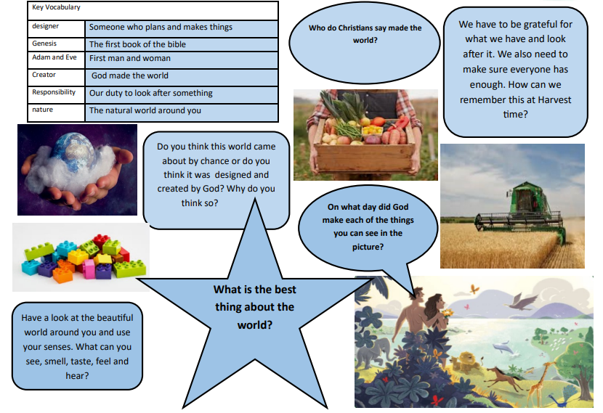
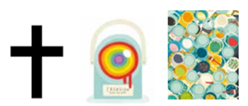
Year 1 – Term 1 – Christianity 1.2 Who do Christians say made the world? Creation

